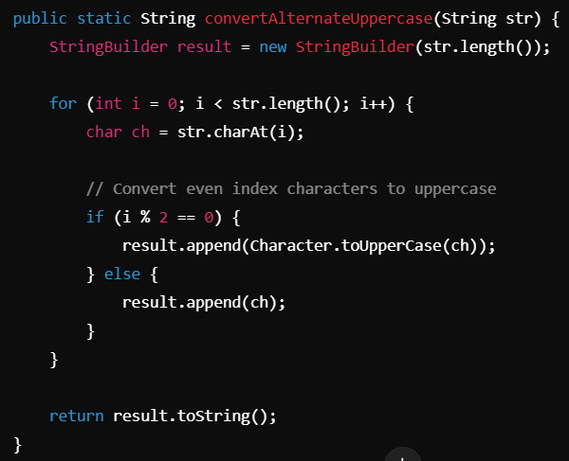
String[] words = sentence.split("\\s+"); // Split by whitespace
String sentence = "apple,banana,grape,orange";
String[] words = sentence.split(",");
String sentence = "apple, banana ,grape , orange";
String[] words = sentence.split("\\s*,\\s*"); // Removes spaces around commas
The trim() method in Java is used to remove leading and trailing whitespace (spaces, tabs, and newlines) from a string. 